DevelopersHub Corporation Red
Teaming

Week 3 : Task

Week 03: Advanced Scanning & Defensive Strategies
Objective : To perform automated vulnerability assessments and analyze advanced defensive mechanisms like WAF and CSP.

Submitted By :
Usman Ghani

DHC ID:
2502

Instructor:
Faizan Khan

Week :
Red Team - Week 3

​Date:
April 21, 2026
1:0 AUTOMATED SCANNING WITH NIKTO

1:1 Objective
The goal of this assignment was to use automated tools to perform a quick security audit of the web server to find common misconfigurations.

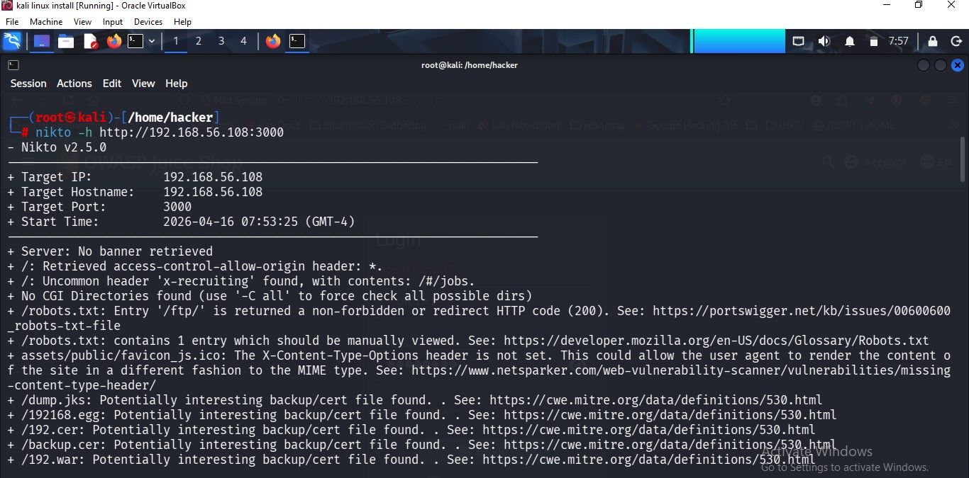

1.2 Observations
The scan identified the target server fingerprint and highlighted potential vulnerabilities in the web server configuration.

2.0 WEB APPLICATION FIREWALL (WAF

2.1 Tool Used: WAFW00F
: We used the WAFW00F tool to identify if any firewall is protecting the target application from common web attacks.

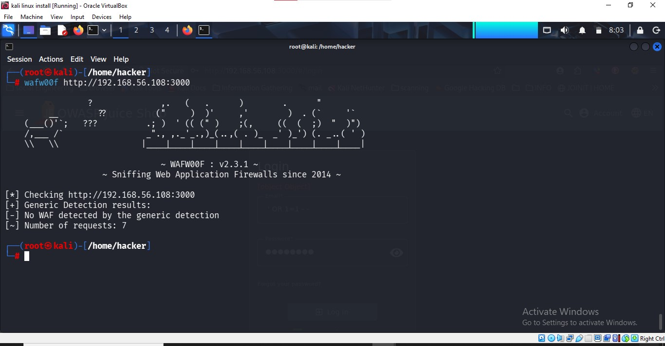

2.2 Result
The tool confirmed that no WAF is currently detected. In professional environments, a WAF is used to filter malicious payloads like SQLi and XSS.

3.0 CONTENT SECURITY POLICY (CSP) ANALYSIS

3.1 Defensive Mechanism
CSP is a modern defense strategy that restricts the browser to only execute scripts from trusted sources, effectively stopping XSS attacks.

3.2 Implementation Example
Content-Security-Policy: script-src 'self';

This policy ensures that even if an attacker injects a script, the browser will refuse to execute it.

4.0 FINAL CONCLUSION
Week 3 demonstrated the power of automation and advanced defensive layers. Combining automated scans with proper security policies like CSP significantly reduces the risk of successful cyber attacks.

